

UGANDA INSTITUTE OF INFORMATION AND COMMMUNICATIONS TECHNOLOGY
PROGRAM : DIPLOMA IN BUSINESS COMPUTING
COURSE UNIT: BUSINESS APPLICATION PROGRAMMING
LECTURER : MR. GEOFREY ODOKONYERO
NAME : KIIZA ASAPH
REG NO. : 2025/DBC/DAY/0850/G

QUESTION ONE:
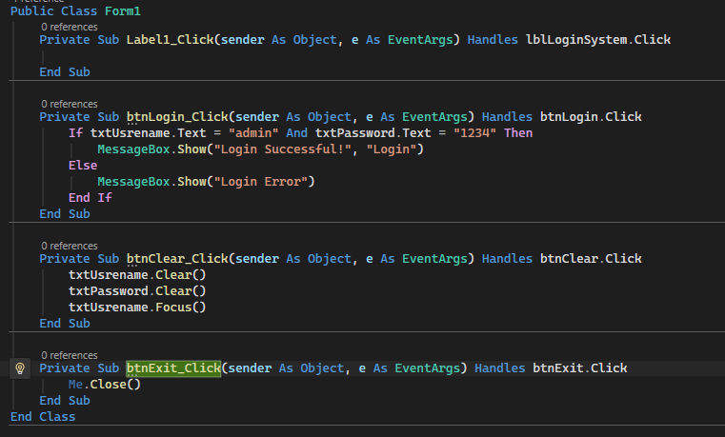
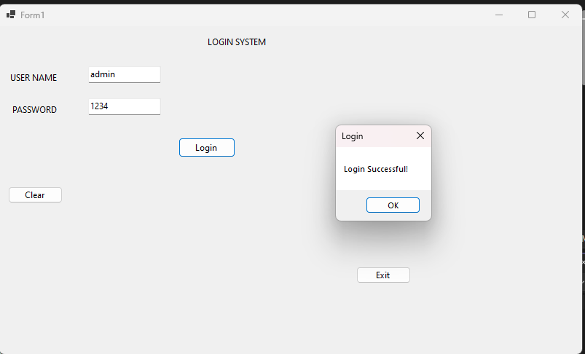

QUESTION TWO:
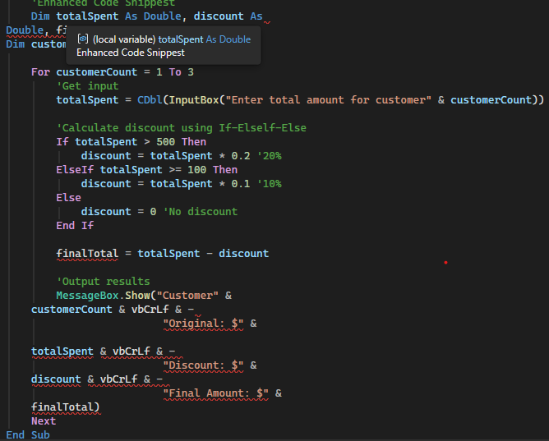

QUESTION THREE:
- Class and Object
Class: A template or blueprint used to create objects. It defines the properties and methods that objects will have. (such as Class Car { Public Color As String} )
Object: A specific instance of that class. It is created from the class and can use its properties and methods. ( for example, Dim MYCAR As New Car)

- Inheritance and Polymorphism:
Inheritance “is-a” relationship. It allows one class to acquire properties and methods from another class. A Sports-car inherits from Car. It reuses code.
Polymorphism: It allows the same method/interface to behave differently in different classes. “Many forms.” A shape class has a Draw (
) method; a circle and square implement Draw ( ) differently.
It promotes flexibility and extensibility
- Encapsulation
Encapsulation is the process of combining data and methods into a class and restricting direct access to some of the data.
For example
Public Class Student

Private age As Integer

Public Property AgeValue
Integer
Get
Return age
End Get
Set(value As Integer)
If value >= 0 Then
age = value

End If
End Set
End Property

End Class

Importance of encapsulation
- Protects data from unauthorized access.
- Improves security by controlling how data is changed
- Makes programs easier to maintain
- Reduces errors by controlling data validation
- Hides implementation details from other parts of the program.
Iv. Constructors and Destructors in VB Classes
Constructors
A constructor is a special procedure that runs automatically when an object is created. In VB.NET, it is normally written using Sub New
Public Class Student

Public Name As String

Public Sub New()
Name = "Unknown"
End Sub

End Class

Destructor
A destructor is used for cleanup when an object is being destroyed. In VB.NET, this is associated with the Finalize mechanism
Protected Overrides Sub
Finalize()
'Cleanup code
Mybase.Finalize()
End sub

Purpose
Constructor: Initializes an object
Destructor/Finalizer: Performs cleanup associated with an object when it is finalized.
QUESTION FOUR:
- Three uses of collections in VB Applications
Use1: Storing a list of items
Collections can store multiple items such as student names
Dim students As New List(Of String)

students.Add("John")
students.Add("Mary")
students.Add("peter")
This allows the application to manage many students without creating a separate variable for each student.
Use 2: Managing records
Collections can store objects such as customers, products or employees
Dim customers As New List(Of String)

customers.Add("Customer 1")
customers.Add("Customer 2")
customers.Add("Customer 3")
This iS useful in business applications for managing records
Use 3:Easy searching and processing
Collections can be looped through to search, display or process data.
For Each student In students
Console.Writeline(student)
Next
This makes it easy to process many items efficiently.
- Message Boxes and their types
A Message Box is a dialog box used by a visual Basic to display information, warning, questions or errors to the user.
Common types of message Boxes
- Information
Used to provide information to the user.
MessageBox.Show("Record saved successfully.",
"Information",
MessageBoxButtons.OK,
MessageBoxIcon.Information)

- Warning
Used to warn the user about a possible problem.
MessageBox.Show("Please check your information.",
"Warning",
MessageBoxButtons.OK,
MessageBoxIcon.Warning)

- Error
Used when an error has occurred.
MessageBox.Show("An error has occured.",
"Error",
MessageBoxButtons.OK,
MessageBoxIcon.Error)

- Question/Confirmation
Used when the application needs a decision from the user.
Dim answer As DialogResult
answer = MessageBox.Show("Do you want to exit?",
"Confirm",
MessageBoxButtons.YesNo,
MessageBoxIcon.Question)
The user can then choose Yes or No
- Solution Explorer in Visual Studio
Solution Explorer is a window in Visual Studio that allows developers to view and manage the files, projects and components of a solution.
It helps with project management by allowing you to:
- View project files such as forms, classes and modules.
- Create new files such as classes and forms
- Open and edit existing files
- Organize project components
- Add references and resources.
- Rename and delete files
- Manage multiple projects within one solution
- Navigate quickly between different parts of the application.
Therefore, Solution Explorer provides a central place for organizing and managing the structure of a visual studio project.

QUESTION FIVE:
